**EQUIFAX**

**Full Install Document**

Doc-To-Help Standard Manual

May 27, 2015

**Contents**

1. EQUIFAX Install Instructions 3

**THIS INTERFACE IS FOR COMPANIES PAYING IN US DOLLARS** 3

**1.0** **Equifax Full Install Documents (zip file)** 3

**1.1** **Equifax Product Types (How to Install)** 3

**1.2** **Contact EQUIFAX** 3

**1.3** **SaaS Customer Info** 3

2. Customer Data Mapping 4

**2.1** **Customer Data Mapping** 4

3. Install 5

**3.1** **Install of the EQUIFAX export.** 5

**3.2** **Install Custom Screen for BackOffice** 5

4. Populate Customer Data 7

**4.1** **Populate Customer Data** 7

5. Backoffice Configuration 14

**5.1** **Backoffice Configuration** 14

6. Manual Configuration 19

7. Running the export 22

**7.1** **Running the export** 22

**7.2** **Sending over History** 22

8. Scheduling 23

9. Troubleshooting 29

**9.1** **Result Codes** 29

# **EQUIFAX Install Instructions**

## **THIS INTERFACE IS FOR COMPANIES PAYING IN US DOLLARS**

CANADA AND GLOBAL RECORDS WILL BE DROPPED BY EQUIFAX

## **Equifax Full Install Documents (zip file)**

To access the most current versions of the install documents, use the link below:

* **Link =>** [**Equifax Full Install**](https://ultimatesoftware.my.salesforce.com/sfc/#version?selectedDocumentId=06932000002N3xs)

## **Equifax Product Types (How to Install)**

**Refer to the Product Code in Salesforce**

* PLUS TALX-UCeXpress - this is Unemployment Cost Management - this product code drives the detailed mapping, not the new, expedited setup.
* PLUS TALX-UCeXpress & The Work Number – this is Unemployment Cost Management AND The Work Number - this combination of product codes drives the detailed mapping, not the new, expedited setup.

WOTC is an additional service with Equifax (140 and 290 records). This does require a full install.

*******PRODUCTS BELOW THIS LINE ARE PART OF THE WORK NUMBER INSTALL******

PLUS TALX-The Work Number **– this is The Work Number** – Income and Employment Verification – this product code, when alone, can use the expedited setup.

## **Contact EQUIFAX**

* Fill out Equifax Implementation form with customer info and send to [*partner@equifax.com*](mailto:partner@equifax.com)
* **Link =>** [Ultimate - CUSTOMER - EQUIFAX - Implementation Form (TEMPLATE)](https://na4.salesforce.com/sfc/#version?selectedDocumentId=06960000001LFWc)

For specific questions about The Work Number implementations, please reach out to:

**Corey Gregg** ([corey.gregg@theworknumber.com](mailto:corey.gregg@theworknumber.com))

For Specific questions about Unemployment implementations, please reach out to:

**Josh Wilkes** ([Joshus.wilkes@equifax.com](mailto:Joshus.wilkes@equifax.com))

***Note:*** *These contacts are for Ultimate only, please do not give this contact to the customer, the customer will have an Equifax Account Manager assigned.*

## **SaaS Customer Info**

* Go to <https://issportal.ultimatesoftware.com> to find the customer information.
* Get AR Number for your customer.

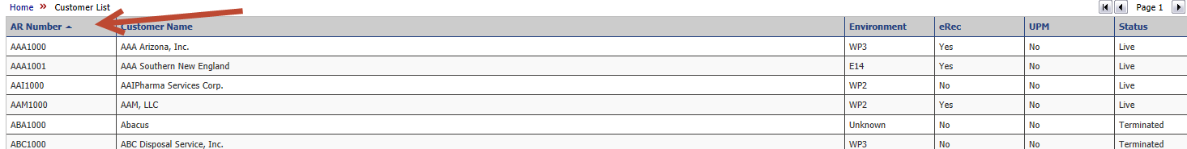

# **Customer Data Mapping**

## **Customer Data Mapping**

* Run Scripts below to get the values to be placed into the Equifax Mapping Worksheet.
* In SQL Management Studio, place results in GRID, so you can copy values into Equifax Mapping Worksheet.
* All mapping must be reviewed / approved by the customer. Provide the customer with an initial mapping, but let them know this is an initial pass at the mapping that they need to approve/change.
* **Company Info Tab**
  + - * 1. CoCode – Info will come from EQUIFAX, 5 digit number
        2. EQUIFAX UCXAccount Number, Info will come from EQUIFAX, 4 digit Alpha Numeric.
* **UltiCountry** - Nothing to be done here.
* **UltiEmployeeType**  - Use the Full Time/Part Time Flag. One value ‘Z’ needs to be in the mapping.
* **UltiEarningCodes** - Translate the Earning Codes. Use the script to get the values

Select ErnEarncode, ErnLongDesc from earncode

where ErnCountryCode = 'USA'

order by ErnEarncode

***Note:*** *Using X as the translated value will exclude the earning from being included in the file,*

* **UltiPayFrequency** - Nothing to be done here
* **Ulti uTermination Reason** - Translate the Term Reasons, Use the script to get values.

select TchCode , TchDesc from TrmReasn

order by TchCode

***Note*:** If Customer decides to use the Full Time/Part Time Flag. One value ‘Z’ needs to be in the mapping.

* Send mapping to the customer.
* Below is a sample email to send to customers.

Hi *****Customer Name****, My name is ****Your Name Here***** I will be assisting you with the EQUIFAX interface. I have attached a mapping document for the mapping of your Earning , Termination and Employee Type Codes.

The tabs on the spreadsheet are highlighted in orange. I have made an initial pass of the mapping, I will need you to confirm or update the codes.

I have also been in contact with EQUIFAX to get the implementation process moving along.

If you would like to discuss, let me know.

Also, let me know if you have any questions.

# **Install**

## **Install of the EQUIFAX export.**

* Run the script in the file **Equifax All Install.sql**

***Note:*** *the script must be run**in the Customer’s Company Database (Ultipro_XXXX)*

## **Install Custom Screen for BackOffice**

* Install with CustPack.exe. Filename => **EEQFX.czp**
* SaaS, go to Desktop, Start, Run, Type In CustPack.exe, Use Admin User ID and Password.
* Install custom Screen (**EEQFX.czp**), use CustPack.exe
* Once you log in, go to Deploy Package.

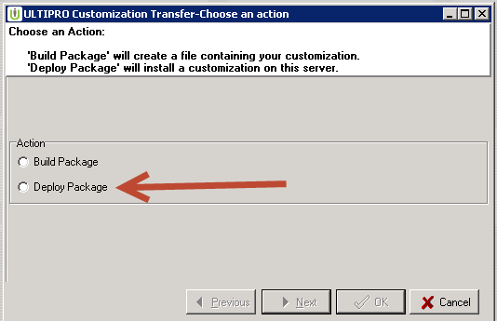

Click next and Browse to your file.

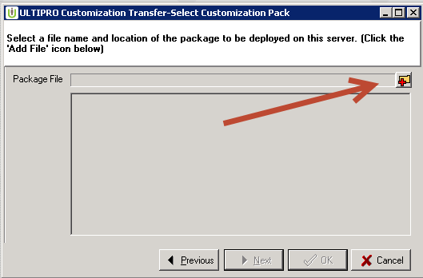

If you get this error, just browse back to the file again.

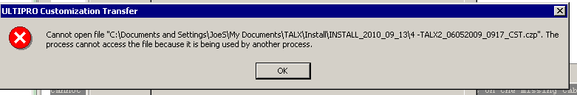

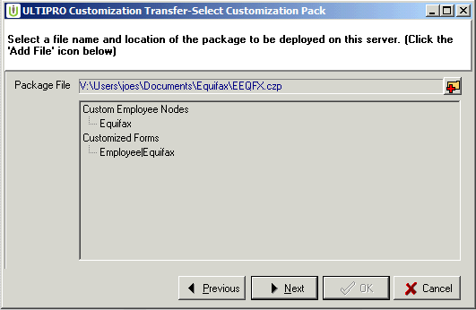

Click next, OK.

Screens are installed in the Backoffice.

***Note:*** *If you get a Borland database error, log out of the Citrix Session, and log back in, usually this fixes the issue.*

# **Populate Customer Data**

## **Populate Customer Data**

* Install Translations either by SQL import or Manually Key.

(Manual Instructions included later in Document)

* If installing via SQL, copy

|  |  |
| --- | --- |
| EEQFX | tEarnCode |
| EEQFX | tucxTermReason |

Values into the **Equifax Client Translations_EEQFX.xls** document.

FormatCode = EEQFX

TransCODE =

tEarncode for Earning codes,

tucxTermreason for Term Reasons.

SrcValue = Source Value from Ultipro

TransValue = Translated Equifax Value

Sample.

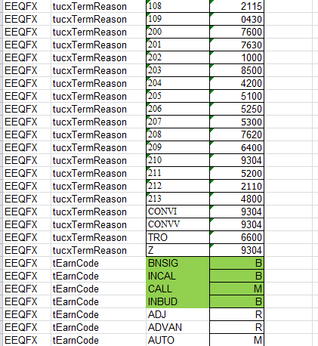

* Import into u_dsi_Translations_v2
* In SQL Management Studio find your database.

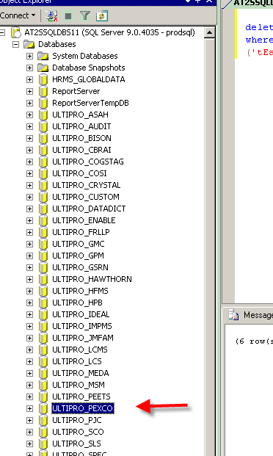

* Right click on the data, Tasks, Import Data.

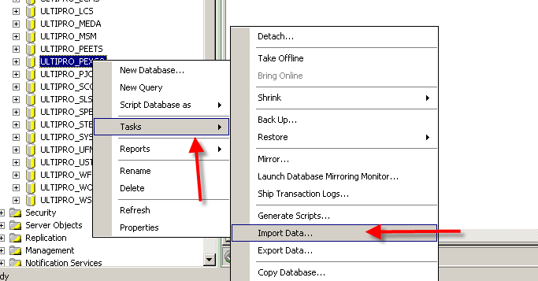

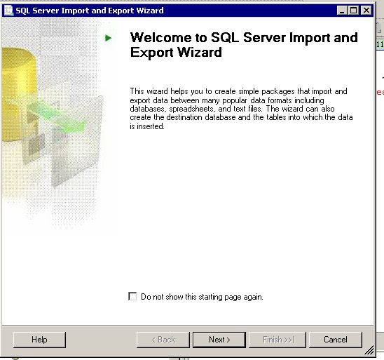

* Click Next

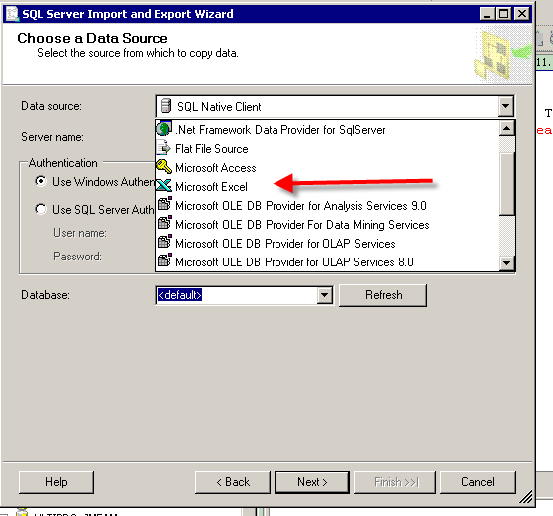

* Data Source is Microsoft Excel

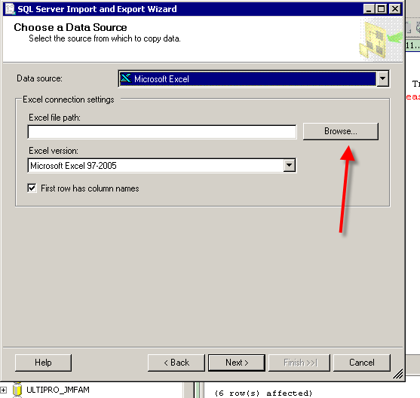

* Browse to find your data

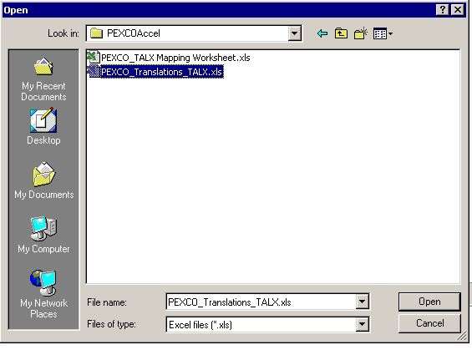

* Select file. Click Next

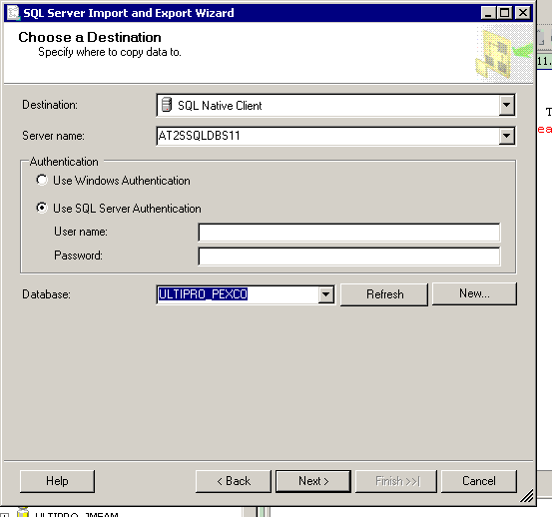

* Enter your SQL user name and password. Click Next

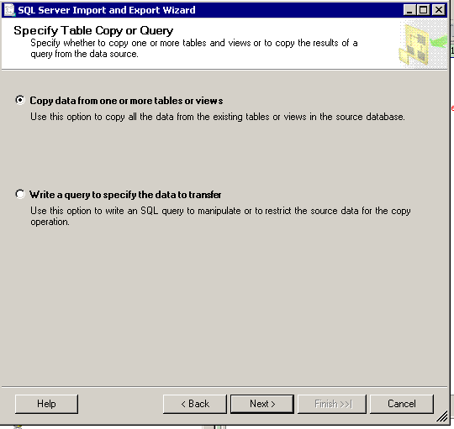

* Select Copy Data from one or more tables or views. Click Next

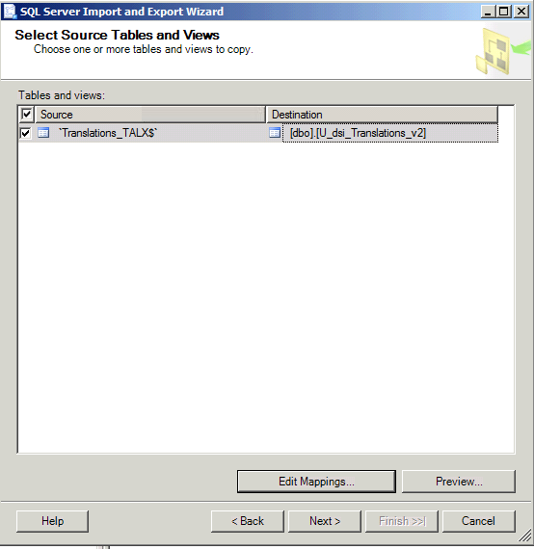

* Under the Destination Column select the U_dsi_Translations_v2 table.
* Click Edit Mappings.

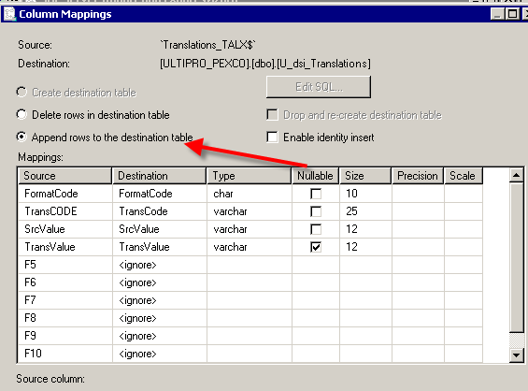

* Verify Append rows to the destination table is selected (that is the default) Click OK, Click Next.
* Click Next , Next , Finish.

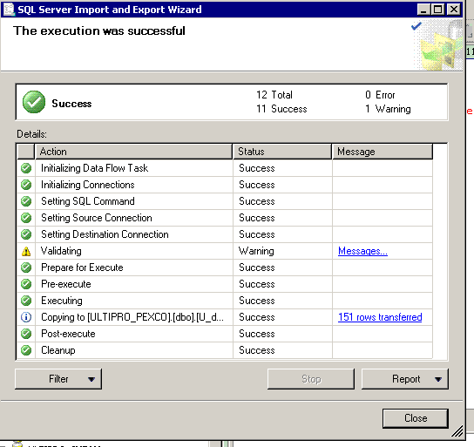

* Success!!

# **Backoffice Configuration**

## **Backoffice Configuration**

* Go to Back Office, Under view Edit, you will see the Equifax Node.

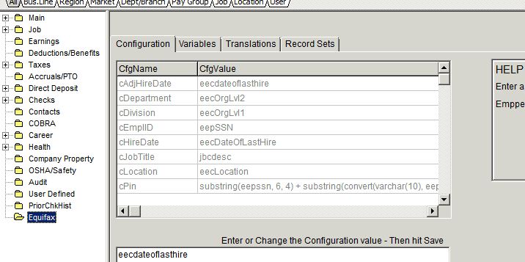

* **Configuration Tab**



In most cases, this table can be left alone.

|  |  |  |
| --- | --- | --- |
| **CfgName** | **CfgValue (Default Values)** | **Explanation** |
| cadjHireDate | Eecdateoflasthire | This date can be altered by putting in the field name, if you need Seniority Date instead enter eecdateofseniority |
| cDepartment | eecOrgLvl2 | This value can be changed to another Org Level or COID, use Field value. This is used for Equifax Reporting. If you use COID, you must send a translation to Equifax. |
| cDivision | eecOrgLvl1 | This value can be changed to another Org Level or COID, use Field value. This is used for Equifax Reporting. If you use COID, you must send a translation to Equifax. |
| cEmplID | eepSSN | Usually left at SSN. This is the employee identifier that is sent on the file |
| cHireDate | eepDateofLastHire | This date can be altered by putting in the field name, if you need Seniority Date instead enter eecdateofseniority |
| Cjobtitle | Jbcdesc | Field can be update to send over jbcdesc, jbcjobcode, eecjobtitle. |
| cLocation | eecLocation | Usually left at Location. This is the work location that is sent to Equifax |
| cPIN | substring(eepssn, 6, 4) + substring(convert(varchar(10), eepdateofbirth, 112), 1, 4) | This is the default password the employee will use to login to the Equifax Website, The site will require the user to change the password . cPin is the employees PIN, Typically it is Last 4 of SSN + YYYY of Date of Birth.. |
| cUserID | eepssn | Employee user ID for Equifax System. |

* Each field must be an exact field name of a field in the EmpComp or EmpPers table. You can only update the FieldName column with the values you need.
* **Variables Tab**

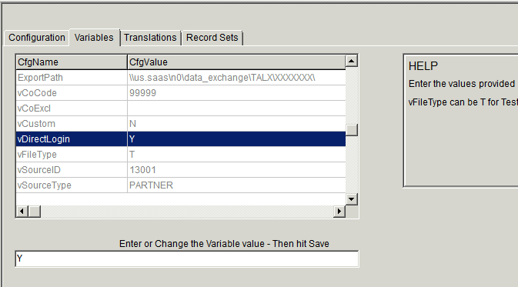

|  |  |  |
| --- | --- | --- |
| **CfgName** | **CfgValue (Default Value** | **Explanation** |
| ExportPath | N Servers  \\us.saas\N0\data_exchange\TALX\AR#\  E Servers  \\us.saas\E0\data_exchange\TALX\AR #\ | **This is where the file is going to be saved.   By using the Data Exchange TALX/Equifax Folders,  the file will automatically get sent to Equifax.  No need to fill out a UDES form.**  **Get AR # from ISS portal.**  **IMPORTANT:   YOU MUST CREATE THE FOLDER with the Customers AR #,  other wise the file will not sent.   Right click in screen to create new folder.** |
| vCoCode | 99999 | This is the Equifax company code    **YOU MUST GET THIS NUMBER.   FILE NAME IS BASED OFF THIS CODE.** |
| vCoExcl |  | To exclude a company , example a successorship ,  we would want to exclude a company from the summing of wages. |
| vCustom | N |  |
| vDirectLogin | Y |  |
| vFileType | T | To change file name from Test to PROD,  values T or P |
| vSourceId | 13001 | Leave value |
| vSourceType | PARTNER | Leave value |
| vSplitFiles | N | Allows the file to be split by vCoCode |
| vTCID | 99999 | Use Equifax company Code |
| vTermDays | 365 | Used to get terms greater than one year |
| vUseSpecChars | N |  |
| vUCXAccountNo | XXXX | Equifax Value |
| Version | 2.0 |  |

* **Translations Tab** (*This is populated via the SQL import or manually*).

***Note:*** *After the configuration is setup, at any time you add a new Earning Code, Pay Frequency, or Employee Type to UltiPro, you must go to this window and add the translation here.*

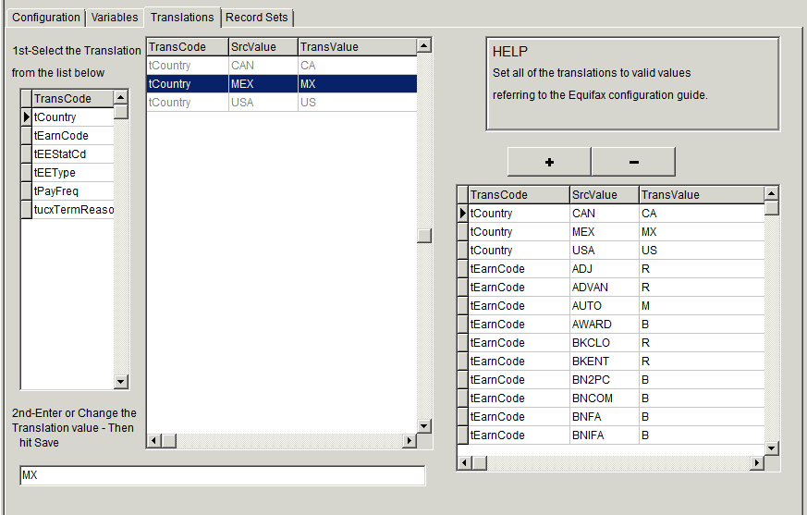

**Additonal Translations can be added. Example, vCoCode. This can be used if company has multiple Equifax Company Codes for USG Component Company.**

**For Example, if the customer needs to report employees with a different Equifax Company code, we can add a translation code of vCoCode, SourceValue would be the Ultipro Component Company code, and the TransValue would be the Equifax Company Code for that Component Company.**

**IMPORTANT!!!!!!**

**In Populating the Record sets, discuss with Equifax what record sets are needed. Typically 202,210 and 220 records are needed. ASK THEM WHAT RECORD SETS ARE NEEDED BASED ON THE SERVICES THE CUSTOMER PURCHASED!!**

**202, 210, 220 , HEADER AND TRAILER ARE STANDARD,**

**140 and 290 Records are needed if the customer has purchased WOTC (Work Opportunity Tax Credit) services.**

**ANY OTHER RECORD TYPES ARE CUSTOM, THEY NEED TO BE REQUESTED VIA SALESFORCE AND THE CUSTOMER WILL INCUR AN ADDITIONAL COST.**

**ANY CHANGES TO THE STANDARD EXPORT WILL INCUR THE CUSTOMER ADDITIONAL COSTS!!!!**

* **Record Sets Tab**

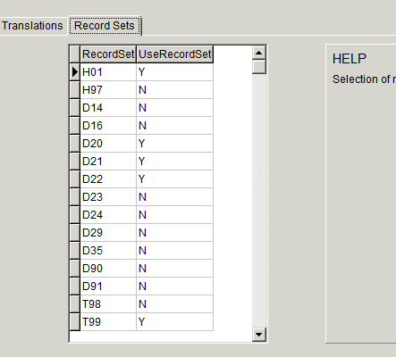

|  |  |  |
| --- | --- | --- |
| **Record Set** | **UseRecordSet** | **Use** |
| H01 |  | Standard Header |
| H97 |  | Header record for I9 setup(custom) |
| D14 |  | 140 Location TAX records (WOTC) |
| D16 |  | 160 Maybe used for I9 setup(custom) |
| D20 |  | 202 |
| D21 |  | 210 |
| D22 |  | 220 |
| D23 |  | 230 Benefits Employee(Custom) |
| D24 |  | 240 Benefits Dependent (Custom) |
| D29 |  | 290 is Employee TAX (WOTC) |
| D35 |  | I9 (Custom) |
| D90 |  | 162 I9 setup (custom) |
| D91 |  | 372 I9 setup (Custom) |
| T98 |  | I9 setup Trailer Record(Custom) |
| T99 |  | Standard Trailer |
| Record Set | UseRecordSet | Use |

**EXPORT SCREEN**

MAKE SURE YOU ONLY CHECK THE COMPANIES PAID IN US DOLLARS ON THE EXPORT SCREEN.

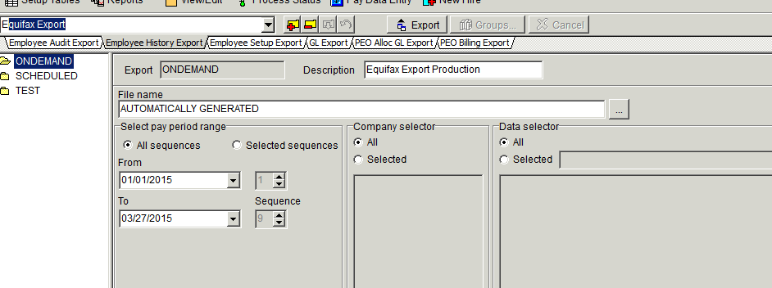

# **Manual Configuration**

* To Manually Change Mapped values , go to the Translations Tab

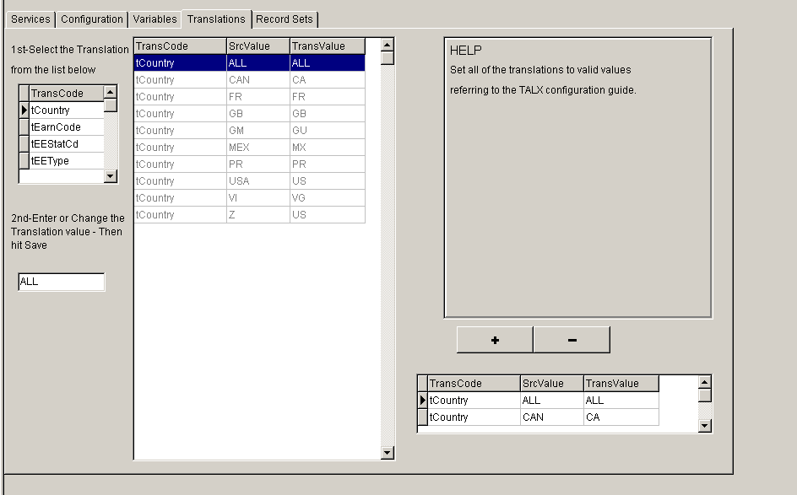

* Scroll through the values. Once you find the value to change, highlight the value.
* The transvalue (Equifax Mapped Value) can be change in the box in lower left corner.

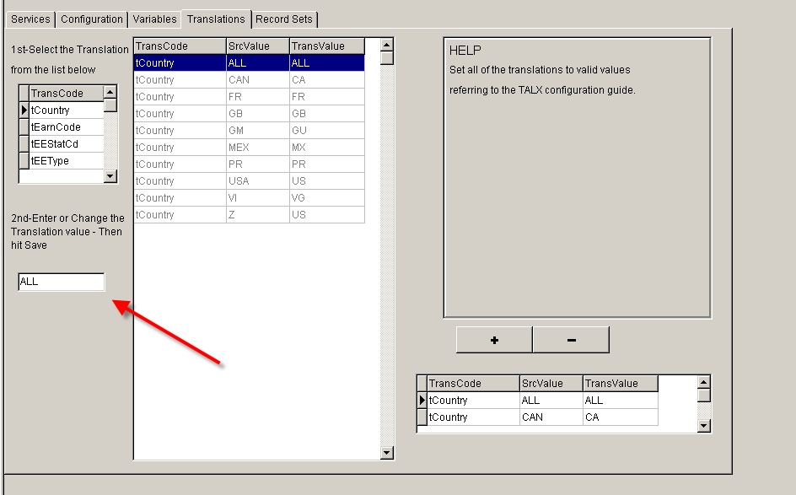

* To manually add a value if there is a new earning code, or a new Term Reason .
* Go to the Translations Tab.
* Click on the Black ‘+’ sign

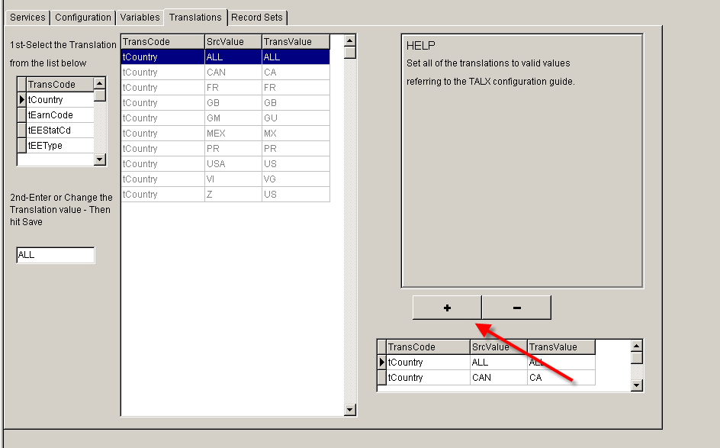

* Fill in the Values

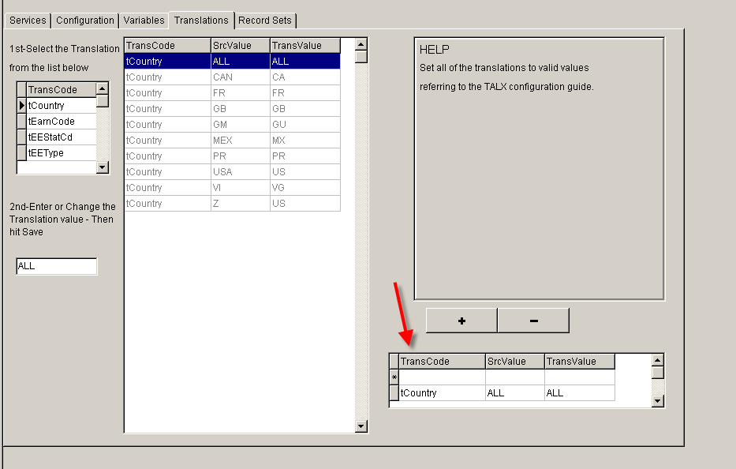

* Click in Transcode box

tCountry , New Country

tEarnCode, New EarnCode

tEEstatCd, New Status Code

tEEType, New Employee Type

tPayFreq, New Pay Frequency

tTermReason, New Term Reason

Populate the Ultipro Code in SrcValue

Populate the Equifax code in TransValue

Click Save

Equifax codes can be located in the **Equifax Mapping Worksheet.xlsx**

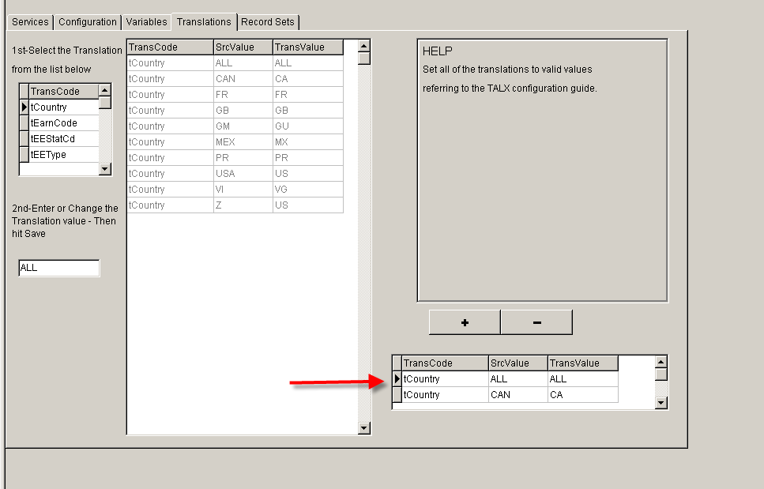

To delete a translation:

* 1. On the bottom of the window, find the value in the box and highlight it.
  2. Click on the minus ‘-‘.
  3. Click **Save**.

# **Running the export**

## **Running the export**

To run the Equifax export on the UltiPro backoffice client workstation:

* Verify that you are logged into UltiPro backoffice. Click Tools, then Exports.
* Click the Employee History Export tab.
* Company Selector does work. Companies can be excluded, examples would be Canada Companies, Garnishment Companies.



* Sessions

ONDEMAND - Manually run file for Testing

SCHEDULED - This is the session that is used if the file is Scheduled to be ran. It is scheduled to run Every Friday at 2 AM EST. The file will capture data from Sequence 2 the previous Friday , until Sequence 1 of the current Friday.

TEST - This Session will send the file as a Test File, even if the File Type is set to P

## **Sending over History**

Typically we can provide Equifax with History files. This is usually 3 years. This can only be done if the checks where created in Ultipro. **This interface does not work with the Prior Payroll History tables.**

To do this,

* change the export path to the customers I drive (us.saas\ENV\Public\AR#)
* Create a folder named Equifax.
* Update your term days as well. 365 for current year, 730 for year 2, 1095 for year 3, ect.
* Create your files. After each file is created, update the file name with the year

***For example.*** *File name 12345TSTin.msf for the year of 2104 would be renamed to 12345TSTin_2014.msf*

* Then take all the history files you created, and copy them all at once to the Equifax UDES directory

*Example (N Servers) us.saas\N0\data_exchange\TALX\AR#*

All the files will then transmit to Equifax. Let your Equifax Consultant know the files have transmitted, and the file names.

# **Scheduling**

* Get into SQL Server Management Studio on the clients SQL server.
* Select SQL Server Agent. Select Jobs.

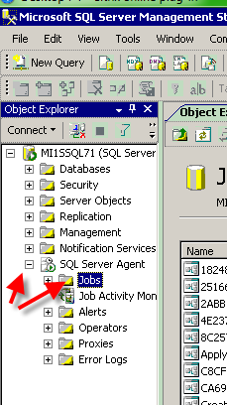

* Right click on Jobs and select New Job

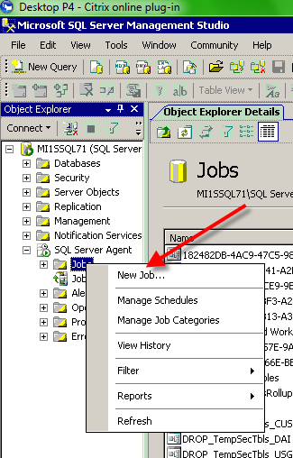

* Enter the job name. Suggested format is E_EEQFX_company name (Friday 3:13 AM).

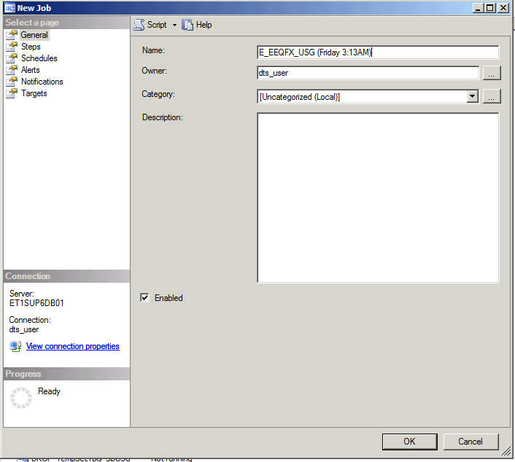

* Select Steps, then New

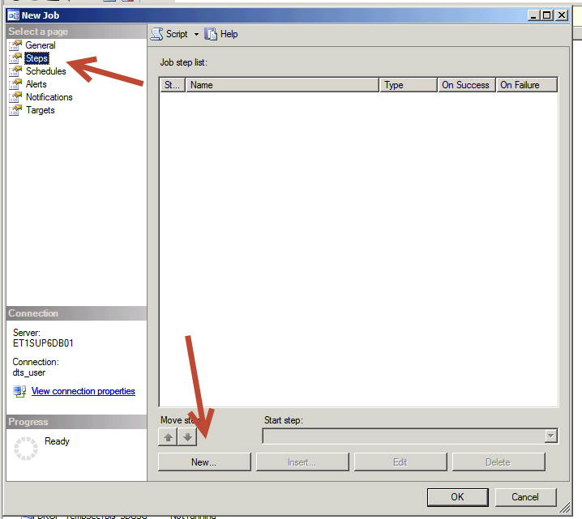

* Enter the Step Name. Suggested format is E_EEQFX. Select the clients database. Paste the following SQL code in the large box.

Equifax_Scheduling.txt

update AscExp

set expLastStartPerControl = convert(varchar(10),getdate()-7,112)+ '2',

expLastEndPerControl = convert(varchar(10),getdate(),112) + '1'

where expFormatCode = 'EEQFX' and expExportCode = 'SCHEDULED'

EXEC dsi_sp_testswitchbox 'EEQFX', 'SCHEDULED'

* Select OK

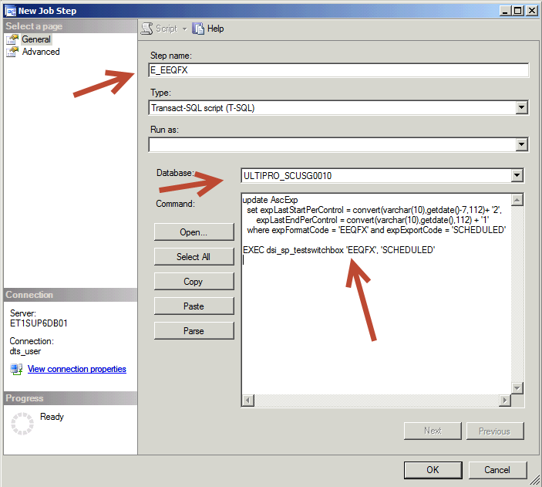

* Select Schedules and New

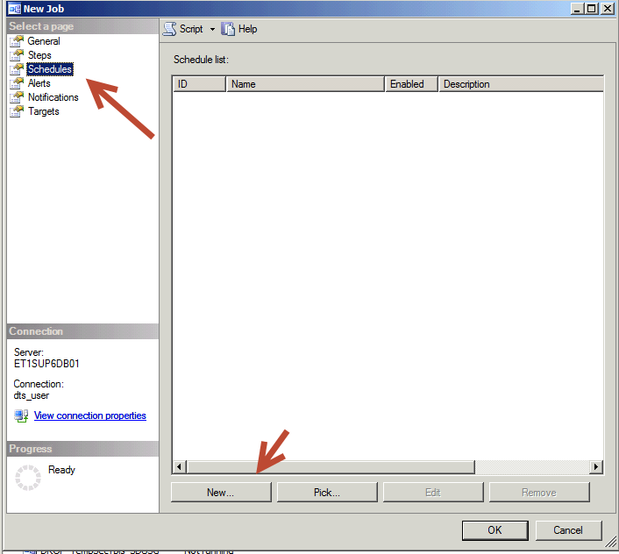

* Enter a Name. Suggested format is EEQFX. Select Occurs Weekly and check Friday. Select Occurs Once At and enter 3:13:00 AM. (For the client’s benefit, this is 3:13 AM Eastern time). Enter the date to start running this job. Select OK.

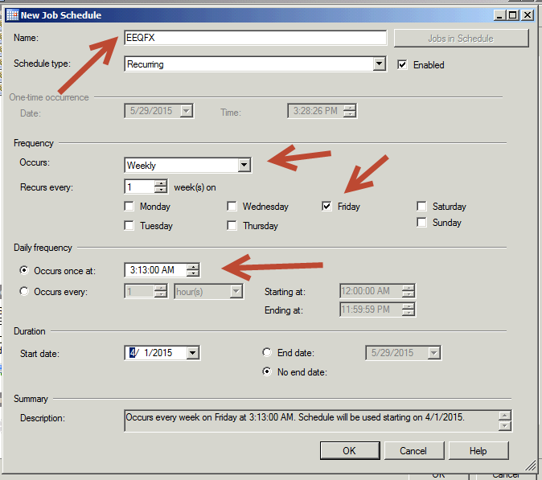

* Click OK again to schedule the job.
* Right click on SQL Server Agent and select Refresh.

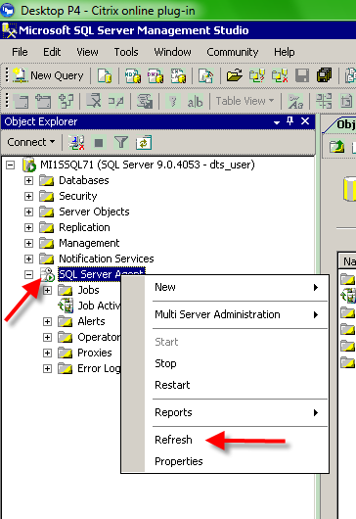

* Expand SQL Server Agent then Jobs. You should see your scheduled Equifax job in the list.

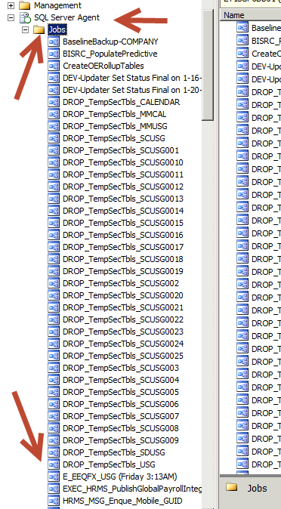

* Get into UltiPro and select Eqiufax

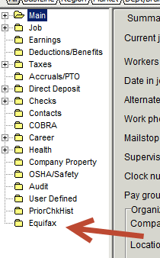

* Select the Variables tab then scroll down to vFileType. Enter a P so the files are sent out as production files. Save the change.

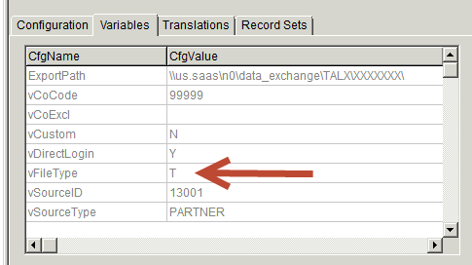

* Go to Exports. Select the Equifax export. Verify that the appropriate selection criteria is checked. The Pay Period Range dates are not used, so just the Company Selector and Data Selector sections need to be reviewed to make sure they’re setup to select the appropriate data.

BE SURE TO UPDATE BOTH THE EEQFX AND SCHEDULED SESSIONS WITH THE APPROPRIATE COMPANIES TO BE TRANSMITTED. US COMPANIES ONLY!!!

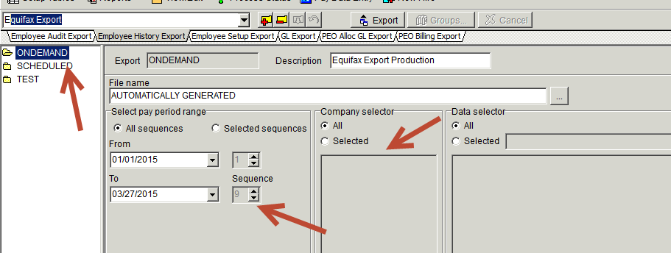

* Save any changes.

# **Troubleshooting**

## **Result Codes**

When running the export, you may receive one of the following codes when the process is complete:

* Positive number is number of 200 records in the export file (individual Employees)
* -66 means the system is locked.

***Note****: Wait a few minutes, run the MS SQL ZAP program and the run the program again*

* -99 means zap (reset).
* -3 means that the bcp out (exporting the table to a text file) for the detail file and the summary both failed, most likely because the export path was unable to be written to by the SQL server.
* -1 means main file failed, -2 means summary failed, -3 (-1 + -2) means both failed.